Q1) Write an MPI program to read N numbers in the root process, distribute them among the processes, find the factorial of each number in parallel, gather the results at the root process, and find the sum of the factorials.

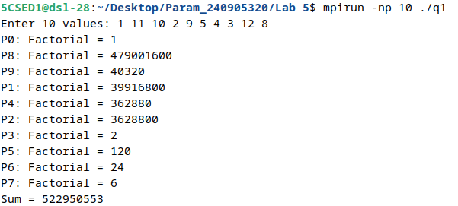

Q2) Write an MPI program to read an integer M and N × M elements in the root process. Send M elements to each process. Each process should find the average of its M elements and send the average to the root process. The root process should collect all the averages and find the total average.

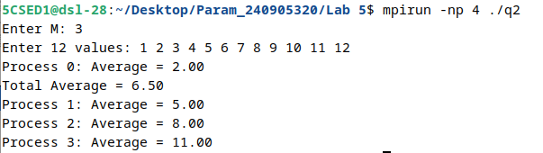

Q3) Write an MPI program to read a string in the root process. Using N processes, where the string length is evenly divisible by N, find the number of non-vowels in the string. The root process should print the number of non-vowels found by each process and the total number of non-vowels.

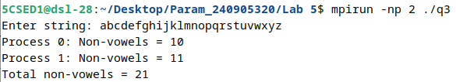

Q4) Write an MPI program to read two strings S1 and S2 of the same length in the root process. Using N processes, where the string length is evenly divisible by N, generate the resultant string using collective communication.

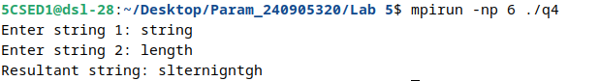

Q5) Write an MPI program to implement parallel selection sort. Use selection sort to sort the subarrays in parallel and then merge the sorted subarrays to obtain the final sorted array.
